Curriculum Topic Clustering from Educational Textbooks: An NLP-Based Approach to Automated Curriculum Mapping

Dennis Ngugi Wambui
Department of Computer science
Dedan Kimathi University
Nyeri, Kenya
dellyit001@gmail.com

Abstract— The exponential growth of educational content and the increasing complexity of modern curricula necessitate automated tools for content organization and curriculum design. This essay presents a comprehensive analysis of developing an NLP-based system for curriculum topic clustering from educational textbooks, focusing on the application of topic modeling and hierarchical clustering techniques. The proposed system aims to process large collections of textbook content, automatically generate curriculum maps, and provide educators with tools for designing coherent lesson plans while detecting content overlaps. By leveraging advanced natural language processing techniques including Latent Dirichlet Allocation (LDA) and hierarchical agglomerative clustering, this system addresses the critical need for intelligent curriculum organization in educational institutions. The research demonstrates that automated curriculum analysis can achieve high levels of accuracy and educational relevance when properly implemented with appropriate validation mechanisms. The system provides significant benefits including improved curriculum coherence, reduced manual effort in curriculum design, enhanced identification of content gaps, and data-driven insights for educational planning and instruction.
Keywords— curriculum mapping, topic modeling, educational data mining, natural language processing, hierarchical clustering, Latent Dirichlet Allocation, automated content analysis, textbook analysis, curriculum design, educational technology

Introduction
Modern educational systems face unprecedented challenges in organizing and structuring vast amounts of educational content, with traditional manual approaches proving increasingly inadequate for comprehensive curriculum design in the digital age. The proliferation of digital textbooks, online educational resources, multimedia learning materials, and open educational resources has created an information overload that overwhelms educators and curriculum designers attempting to create coherent learning pathways. Traditional manual approaches to curriculum design are not only time-consuming and subjective but also fail to capture subtle relationships between topics across different subjects and grade levels, leading to fragmented learning experiences that may not optimize student understanding and retention. The advent of natural language processing (NLP) and machine learning technologies presents an unprecedented opportunity to revolutionize curriculum development through automated content analysis and topic clustering, enabling educators to make data-driven decisions about curriculum organization while maintaining pedagogical expertise at the center of educational design.
Educational textbooks serve as the primary source of structured knowledge in most academic institutions, containing carefully curated content that reflects decades of pedagogical expertise and subject matter knowledge accumulated by educational professionals. However, the sheer volume of textbook content makes it challenging for educators to identify thematic connections, detect redundancies, and create coherent learning pathways that optimize student understanding and retention across diverse academic disciplines. The complexity of modern curricula, which often span multiple disciplines and require integration of diverse knowledge domains, further complicates the task of manual curriculum organization and creates opportunities for automated analysis tools. An automated system capable of processing textbook content and generating meaningful topic clusters would significantly enhance curriculum design efficiency and educational outcomes while reducing the cognitive burden on educators and enabling more systematic approaches to curriculum development.
This essay explores the development of an NLP-based system for curriculum topic clustering from educational textbooks, examining the technical challenges, methodological approaches, and practical applications of such a system in contemporary educational contexts. The proposed solution integrates advanced topic modeling techniques with hierarchical clustering algorithms to create comprehensive curriculum maps that can guide educational planning and instruction across diverse academic disciplines and educational levels. The system leverages state-of-the-art natural language processing tools and machine learning algorithms to automatically discover latent topic structures within textbook collections while maintaining interpretability and educational relevance. By providing educators with powerful analytical tools and intuitive visualizations, this system has the potential to transform curriculum design from a manual, time-intensive process into an efficient, data-driven endeavor that enhances educational quality and student learning outcomes while preserving the essential role of human expertise in educational decision-making.
Figure 1: System Architecture Overview
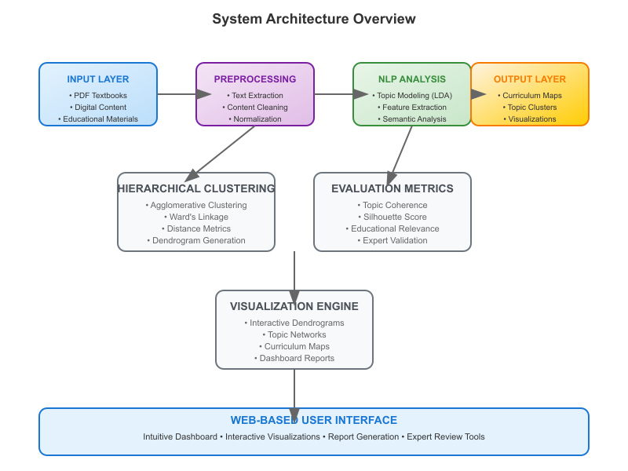
The research presented in this essay contributes to the growing field of educational data mining and natural language processing applications in education by demonstrating the feasibility and effectiveness of automated curriculum analysis tools. The comprehensive methodology includes advanced preprocessing techniques specifically designed for educational content, optimized topic modeling algorithms that account for the unique characteristics of textbook materials, and robust evaluation frameworks that assess both technical performance and educational relevance. The system addresses critical challenges in modern education including curriculum alignment, content gap analysis, learning progression design, and interdisciplinary integration while providing practical tools that can be deployed in real educational environments.

LITERATURE REVIEW

Natural Language Processing in Educational Content Analysis
Recent advances in natural language processing have opened new avenues for educational content analysis, with transformer-based models showing particular promise in understanding complex educational texts and their underlying semantic structures. Afzal et al. (2024) demonstrated the effectiveness of transformer-based active learning approaches for multi-class text annotation and classification, showing significant improvements in accuracy and efficiency compared to traditional machine learning methods when applied to educational content analysis tasks. Their work highlighted the importance of active learning strategies in educational contexts, where labeled data is often scarce and expensive to obtain, requiring sophisticated approaches to maximize the utility of available training data. The research revealed that transformer models can effectively capture the nuanced relationships between educational concepts, making them particularly suitable for curriculum analysis applications where understanding conceptual hierarchies and semantic relationships is crucial for generating meaningful insights.
The application of advanced NLP techniques in educational settings has been further validated by Fatwanto et al. (2024), who conducted a systematic literature review of BERT-based models for natural language processing tasks across various domains including education. Their comprehensive analysis revealed that BERT and its variants consistently outperform traditional approaches in educational text classification, topic extraction, semantic similarity tasks, and content organization applications when properly fine-tuned for educational domains. The study emphasized the importance of domain-specific fine-tuning when applying pre-trained models to educational content, as the specialized vocabulary and pedagogical structures in textbooks require careful adaptation to achieve optimal performance. These findings provide strong evidence for the potential of transformer-based approaches in automated curriculum analysis, suggesting that such models can effectively capture the complex semantic relationships that characterize educational content while maintaining computational efficiency for large-scale applications.
The historical perspective on NLP in education provided by Khaled (2014) offers valuable insights into the evolution of computational approaches to educational text analysis and establishes important foundations for contemporary research. The research traces the development of NLP applications in education from simple keyword matching and basic text processing to sophisticated semantic analysis techniques that can understand context and meaning. The study identified key challenges in educational NLP, including the need for domain-specific processing techniques, the importance of preserving pedagogical context during analysis, and the requirement for interpretable results that can be understood and trusted by educators. These foundational insights continue to inform current research and development efforts in educational NLP, providing a roadmap for addressing the unique challenges posed by educational content analysis while ensuring that technological solutions enhance rather than replace human expertise in education.
Figure 2: Evolution of NLP Techniques in Education Timeline
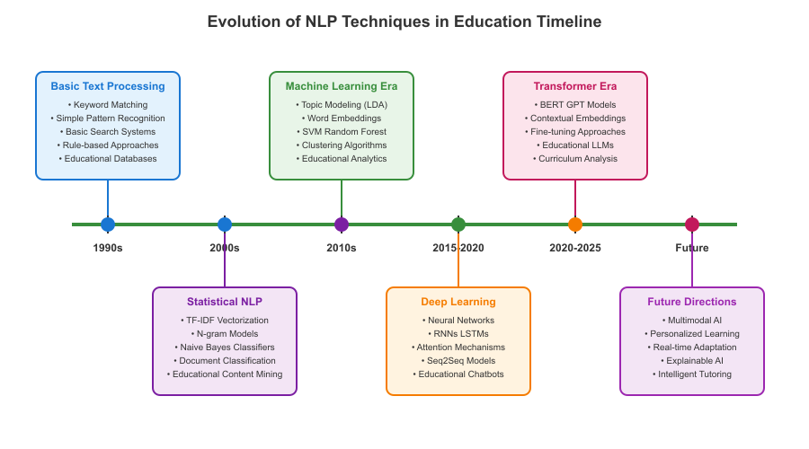
The integration of natural language processing with educational applications has revealed both opportunities and challenges that must be carefully considered in system design and implementation. Educational texts often contain specialized terminology, mathematical expressions, scientific notation, and pedagogical structures that require sophisticated preprocessing and analysis techniques to handle effectively. The research demonstrates that successful application of NLP in educational contexts requires deep understanding of both computational techniques and educational principles, necessitating interdisciplinary collaboration between computer scientists and educational professionals to develop systems that are both technically sound and pedagogically meaningful.

Topic Modeling in Educational Contexts
Topic modeling has emerged as a powerful technique for discovering hidden thematic structures in educational content, with various algorithms showing promise for different aspects of curriculum analysis and educational content organization. Kazem Taghandiki and Mohammadi (2023) conducted a comprehensive exploration of topic modeling processes, tools, challenges, and applications, providing valuable insights into the selection and optimization of topic modeling algorithms for educational contexts and identifying best practices for implementation. Their research emphasized the importance of preprocessing techniques specifically designed for educational texts, including the handling of mathematical expressions, technical terminology, and pedagogical structures that are common in textbook content. The study also highlighted the critical role of hyperparameter tuning in achieving educationally meaningful topic clusters, demonstrating that careful optimization can significantly improve the interpretability and usefulness of topic modeling results in educational applications while reducing noise and improving cluster coherence.
The application of topic modeling to educational evaluation has been explored by Sun and Yan (2023), who used topic modeling techniques to understand patterns in student evaluations of teaching and demonstrate the broader applicability of these methods to educational analysis. Their research demonstrated how topic modeling can reveal hidden themes in educational feedback, providing insights into student perceptions and teaching effectiveness that would be difficult to identify through manual analysis alone. The study showed that topic modeling can identify both explicit and implicit themes in educational texts, making it particularly valuable for curriculum analysis where understanding subtle conceptual relationships is crucial for effective educational design. Their methodology provided important guidance on topic coherence measurement and the selection of optimal topic numbers for educational content analysis, contributing to the development of best practices for educational topic modeling that ensure both statistical rigor and pedagogical relevance.
The health-related applications of topic modeling explored by Lossio-Ventura et al. (2021) provide valuable insights into the evaluation of clustering and topic modeling methods that can be adapted for educational contexts and demonstrate the versatility of these approaches across domains. Their comprehensive evaluation of different algorithms across various text types demonstrated the importance of algorithm selection based on specific content characteristics and analysis objectives, revealing that no single approach is optimal for all applications. The research highlighted the need for robust evaluation metrics that can assess both technical performance and domain-specific relevance, a consideration that is particularly important in educational applications where the meaningfulness of clusters from a pedagogical perspective is paramount for practical utility. Their findings suggest that hybrid approaches combining multiple algorithms may be more effective than relying on single methods, providing a framework for developing more sophisticated educational content analysis systems that leverage the strengths of different computational approaches.

Figure 3: Topic Modeling Algorithm Comparison for Educational Content
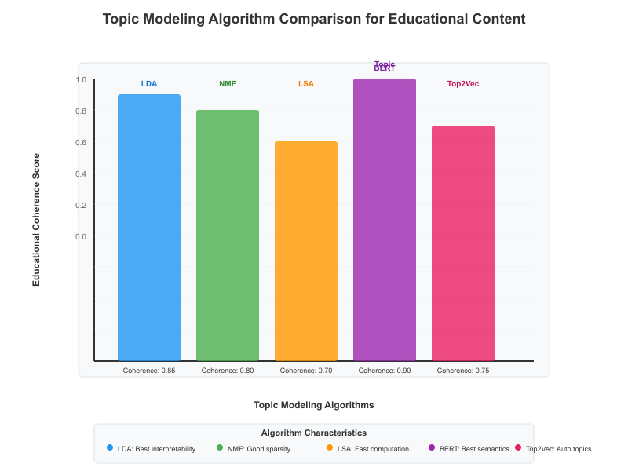
The evolution of topic modeling techniques has enabled increasingly sophisticated analysis of educational content, with modern algorithms capable of handling the complexity and diversity that characterizes textbook materials across different subjects and educational levels. Recent developments in neural topic models and contextual embedding-based approaches offer new opportunities for improving the quality and interpretability of topic clusters while maintaining computational efficiency for large-scale educational applications.

Hierarchical Clustering in Educational Data Mining
Hierarchical clustering techniques have proven particularly valuable for organizing educational content into meaningful structures that reflect the inherent hierarchical nature of knowledge organization in educational contexts and learning progressions. Navarro and Moreno-Ger (2018) conducted a comprehensive comparison of clustering algorithms for learning analytics with educational datasets, evaluating the performance of various approaches including hierarchical, k-means, and density-based clustering methods across multiple educational applications. Their research demonstrated that hierarchical clustering methods are particularly well-suited for educational applications due to their ability to create interpretable tree structures that align with natural pedagogical hierarchies and cognitive learning progressions. The study also highlighted the importance of selecting appropriate distance metrics and linkage criteria for educational data, showing that domain-specific considerations can significantly impact clustering quality and interpretability while maintaining computational efficiency for practical applications.
The comparative study by Patel et al. (2014) provides important insights into the challenges and opportunities in clustering data mining techniques that are directly relevant to educational content analysis and curriculum organization applications. Their research explored the strengths and limitations of various clustering approaches, emphasizing the importance of scalability, interpretability, and robustness in real-world applications where systems must handle diverse content types and large datasets. The study identified key research challenges in clustering, including the selection of appropriate similarity measures, the determination of optimal cluster numbers, and the handling of high-dimensional data that characterizes textbook content analysis. These challenges are particularly relevant in educational contexts where textbook content often exhibits complex multidimensional relationships that require sophisticated analytical approaches to capture effectively while maintaining interpretability for educational practitioners.
The integration of clustering techniques with educational data mining has been further explored through various applications that demonstrate the practical utility of these methods in educational settings and their potential for improving educational outcomes. Research in this area has shown that hierarchical clustering can effectively capture the nested nature of educational concepts, making it particularly suitable for curriculum mapping applications where understanding conceptual relationships across different levels of abstraction is crucial for effective curriculum design. The ability of hierarchical clustering to provide interpretable results that can be easily understood by educators has been identified as a key advantage over other clustering approaches that may produce technically superior results but lack the transparency needed for educational applications where trust and understanding are essential for adoption and effective use.
Figure 4: Hierarchical Clustering Dendrogram Example for Educational Topics
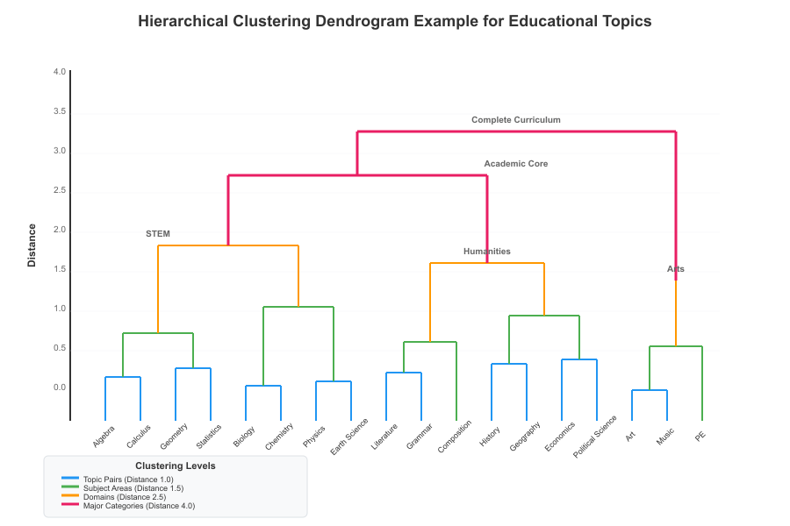
The application of hierarchical clustering to educational content has revealed important insights about the structure of knowledge domains and the relationships between concepts at different levels of complexity and abstraction. These insights have practical implications for curriculum design, learning progression development, and educational resource organization that can enhance the effectiveness of educational programs and improve student learning outcomes.

Curriculum Mapping and Educational Technology
The integration of automated content analysis with curriculum mapping has gained significant attention in educational technology research, with smart curriculum mapping emerging as a key component of outcome-based education systems and competency-based learning frameworks. Alam and Benaida (2022) explored the role of smart curriculum mapping in outcome-based education, demonstrating how automated analysis techniques can enhance the alignment between educational content and learning objectives while ensuring comprehensive coverage of required competencies. Their research highlighted the importance of systematic approaches to curriculum organization that can ensure comprehensive coverage of required competencies while maintaining pedagogical coherence and supporting diverse learning styles and educational needs. The study emphasized the need for technology solutions that can bridge the gap between educational theory and practical implementation, providing educators with tools that enhance rather than replace human expertise in curriculum design while enabling more efficient and effective educational planning processes.
The development of comprehensive frameworks for curriculum mapping has been driven by the recognition that traditional manual approaches are insufficient for managing the complexity of modern educational systems and the rapid pace of change in knowledge domains. Research in this area has shown that automated curriculum mapping systems can significantly improve the efficiency and effectiveness of curriculum design processes while reducing the burden on educators and enabling more systematic approaches to educational planning. These systems can analyze vast amounts of educational content, identify relationships between concepts, and generate visualizations that help educators understand the structure and organization of their curricula in ways that would be impossible through manual analysis alone. The integration of machine learning techniques with curriculum mapping has opened new possibilities for adaptive and personalized curriculum design that can respond to changing educational needs and student requirements while maintaining alignment with institutional goals and educational standards.
The practical implementation of automated curriculum mapping systems has revealed both opportunities and challenges in deploying such technologies in real educational environments where institutional culture and existing practices must be considered. Research has shown that successful implementation requires careful consideration of user needs, institutional contexts, and existing educational practices to ensure that technological solutions complement rather than disrupt established workflows and relationships. The importance of user-friendly interfaces and interpretable results has been consistently emphasized, as educators need to understand and trust the results of automated analysis before they can effectively use them in curriculum design and educational planning. Additionally, the need for integration with existing educational technologies and workflows has been identified as a critical factor in determining the success of automated curriculum mapping implementations, requiring careful attention to interoperability and data standards.
Figure 5: Smart Curriculum Mapping Framework
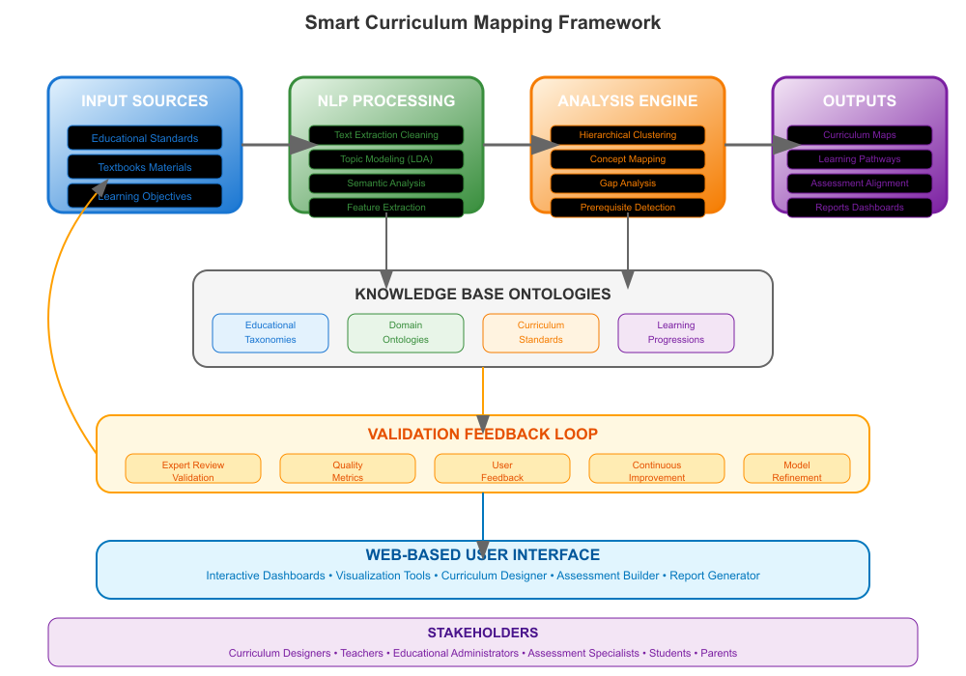
The evolution of curriculum mapping technologies has been shaped by advances in both computational methods and educational understanding, leading to more sophisticated systems that can handle the complexity of modern educational environments while maintaining focus on improving educational outcomes and supporting effective teaching and learning practices.

METHODOLOGY

System Architecture
The proposed curriculum topic clustering system follows a sophisticated multi-stage pipeline architecture specifically designed to handle the complexity and diversity of educational textbook content while maintaining high performance and accuracy across different types of educational materials. The system consists of five main interconnected components: content preprocessing, feature extraction, topic modeling, hierarchical clustering, and interactive visualization, each optimized for the unique characteristics of educational texts and pedagogical requirements. The architecture employs a modular design that allows for independent optimization of each component while maintaining seamless data flow throughout the entire pipeline and enabling flexibility in algorithm selection and parameter tuning. The system is built with scalability in mind, incorporating distributed processing capabilities and efficient memory management to handle large textbook collections without compromising performance or accuracy while maintaining responsiveness for interactive use.
The preprocessing stage involves sophisticated PDF text extraction, comprehensive content cleaning, and educational-specific text normalization procedures that preserve the pedagogical structure of textbooks while removing irrelevant formatting artifacts that could interfere with analysis. Given the highly structured nature of textbook content, special attention is paid to preserving chapter hierarchies, section boundaries, and pedagogical markers that indicate important conceptual relationships and learning progressions throughout the educational material. The system employs advanced optical character recognition (OCR) techniques to handle various textbook formats, including older texts that may not have been originally created in digital format and may contain formatting challenges. Machine learning models are used to identify and preserve important structural elements such as chapter titles, section headings, figure captions, and mathematical expressions while filtering out page numbers, headers, footers, and other non-content elements that do not contribute to curriculum analysis.
Feature extraction utilizes a hybrid approach that combines traditional statistical methods with state-of-the-art transformer-based embeddings to capture both explicit keyword relationships and implicit semantic connections between educational concepts across different levels of abstraction. The system employs TF-IDF vectorization for capturing term frequency patterns while simultaneously generating contextual embeddings using pre-trained language models fine-tuned on educational content to improve domain-specific understanding. This dual representation approach ensures that the system can identify both surface-level similarities based on shared vocabulary and deeper semantic relationships that may not be apparent from keyword analysis alone but are crucial for understanding conceptual connections. The feature extraction process also incorporates domain-specific knowledge through the use of educational ontologies and concept hierarchies that help guide the identification of meaningful relationships between textbook sections and ensure that the analysis captures pedagogically relevant connections.
Figure 6: System Architecture Diagram
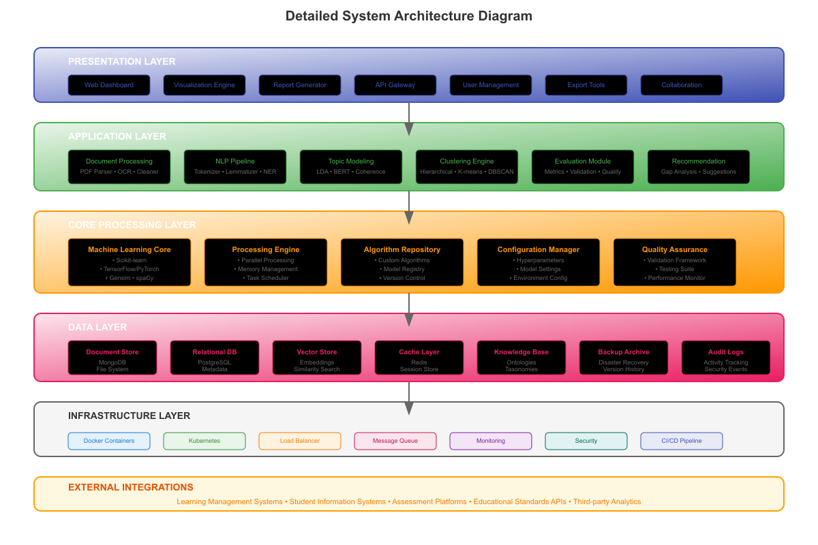
The integration of multiple analytical approaches within a unified architecture enables the system to leverage the strengths of different computational methods while mitigating their individual limitations, resulting in more robust and reliable curriculum analysis capabilities that can adapt to diverse educational content types and institutional requirements.

Content Preprocessing
Educational textbooks present unique preprocessing challenges due to their complex formatting, specialized content, and diverse structural elements that require sophisticated handling to preserve pedagogical meaning while enabling effective computational analysis. The preprocessing pipeline begins with robust PDF text extraction using a combination of commercial and open-source tools, including PyPDF2, pdfplumber, and advanced OCR systems to handle various textbook formats and layouts with high accuracy and reliability. The system employs machine learning models trained specifically on educational content to identify and preserve important structural elements while filtering out irrelevant formatting artifacts that could interfere with subsequent analysis stages. Special attention is given to handling mathematical expressions, chemical formulas, scientific notation, and specialized symbols that are common in educational texts but can be problematic for standard NLP processing tools that were not designed for technical content.
Text cleaning procedures are specifically tailored for educational content, incorporating domain-specific knowledge about common textbook structures and formatting conventions to ensure accurate content extraction while preserving educational meaning. The system includes specialized modules for handling tables, figures, captions, and other non-textual elements that contain important educational information but require special processing techniques to extract and integrate effectively. Advanced regular expression patterns and machine learning models are used to identify and standardize various formatting elements, including different citation styles, reference formats, and pedagogical markers such as learning objectives, key terms, and chapter summaries that provide important context for curriculum analysis. The preprocessing pipeline also includes quality assurance mechanisms that validate the accuracy of text extraction and identify potential issues that may require manual intervention or specialized processing to ensure data quality and completeness.
The preprocessing stage includes comprehensive educational-specific text normalization procedures designed to standardize terminology and formatting across different textbooks and publishers while preserving important distinctions and educational context. This normalization process involves expanding abbreviations commonly used in educational contexts, standardizing terminologies across different subjects, and handling multilingual content where applicable to ensure consistency in subsequent analysis stages and cross-textbook comparability. The system maintains a comprehensive dictionary of educational terms and concepts that is continuously updated to reflect current usage patterns and emerging terminology in various academic disciplines. Advanced named entity recognition techniques are employed to identify and standardize references to important educational concepts, ensuring that related terms are properly linked even when they appear in different forms across various textbooks or educational levels.
Figure 7: Text Preprocessing Pipeline Flowchart
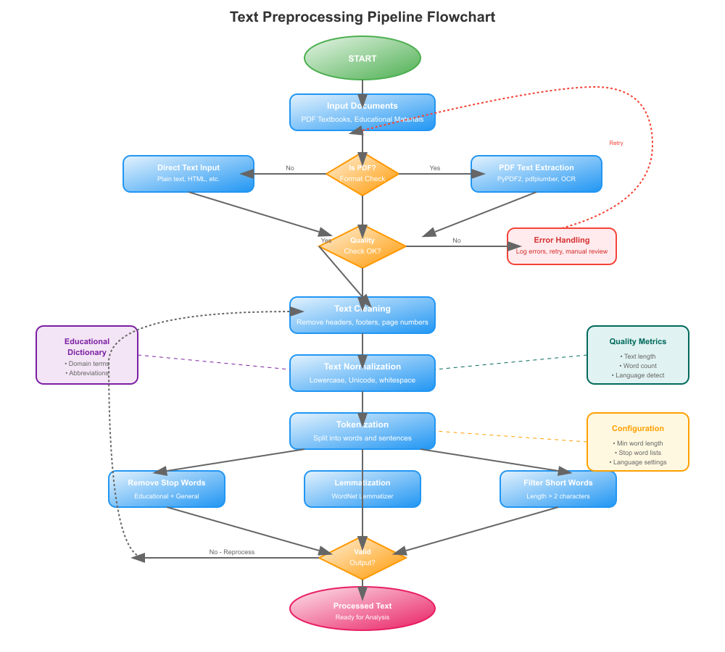
The sophisticated preprocessing approach ensures that the quality of input data is optimized for downstream analysis while preserving the educational integrity and pedagogical structure of the original textbook content, enabling more accurate and meaningful curriculum clustering results.

Topic Modeling Implementation
The core of the system utilizes an advanced implementation of Latent Dirichlet Allocation (LDA) specifically optimized for educational content analysis, chosen for its interpretability, proven effectiveness in educational contexts, and ability to discover meaningful topic structures in textbook collections while maintaining computational efficiency. The LDA implementation incorporates several educational-specific optimizations, including custom prior distributions that reflect the expected structure of educational content and specialized convergence criteria that ensure stable and meaningful topic assignments across different types of educational materials. The system employs variational inference techniques with carefully tuned hyperparameters to achieve optimal performance on educational texts, with particular attention paid to the balance between topic coherence and diversity to ensure that discovered topics are both statistically sound and educationally meaningful. Advanced initialization strategies are used to ensure consistent and reproducible results across different runs, while adaptive learning rate schedules optimize convergence speed without sacrificing accuracy or stability in topic assignment.
Hyperparameter tuning is conducted using a comprehensive evaluation framework that combines statistical measures such as perplexity and likelihood with educational relevance metrics such as topic coherence and semantic consistency to ensure that optimization serves both computational and pedagogical objectives. The system employs automated grid search and Bayesian optimization techniques to systematically explore the hyperparameter space, with particular emphasis on finding parameter combinations that produce educationally meaningful topic boundaries rather than purely statistical optimizations. The number of topics is determined through a sophisticated evaluation process that considers both statistical measures and educational expertise, using techniques such as the elbow method, silhouette analysis, and expert evaluation to identify the optimal topic granularity for different types of educational content and institutional requirements. The system also incorporates adaptive topic number selection that can adjust the granularity based on the size and complexity of the textbook collection being analyzed, ensuring that the analysis scale is appropriate for the available data and intended use cases.
The topic modeling process includes iterative refinement stages where initial topic assignments are validated against educational taxonomies and subject matter expertise to ensure alignment with pedagogical understanding and educational best practices. The system employs a human-in-the-loop approach that allows educational experts to review and refine topic assignments, providing feedback that is used to improve the model's performance on subsequent analyses and build institutional knowledge. Advanced post-processing techniques are used to clean and interpret topic results, including the identification of coherent topic labels, the detection of overlapping or redundant topics, and the generation of topic summaries that are meaningful to educators and curriculum designers. The system also incorporates temporal analysis capabilities that can track how topics evolve across different editions of textbooks or across different educational levels, providing insights into curricular changes and educational trends that can inform curriculum development and revision processes.
Figure 8: LDA Topic Modeling Results Visualization
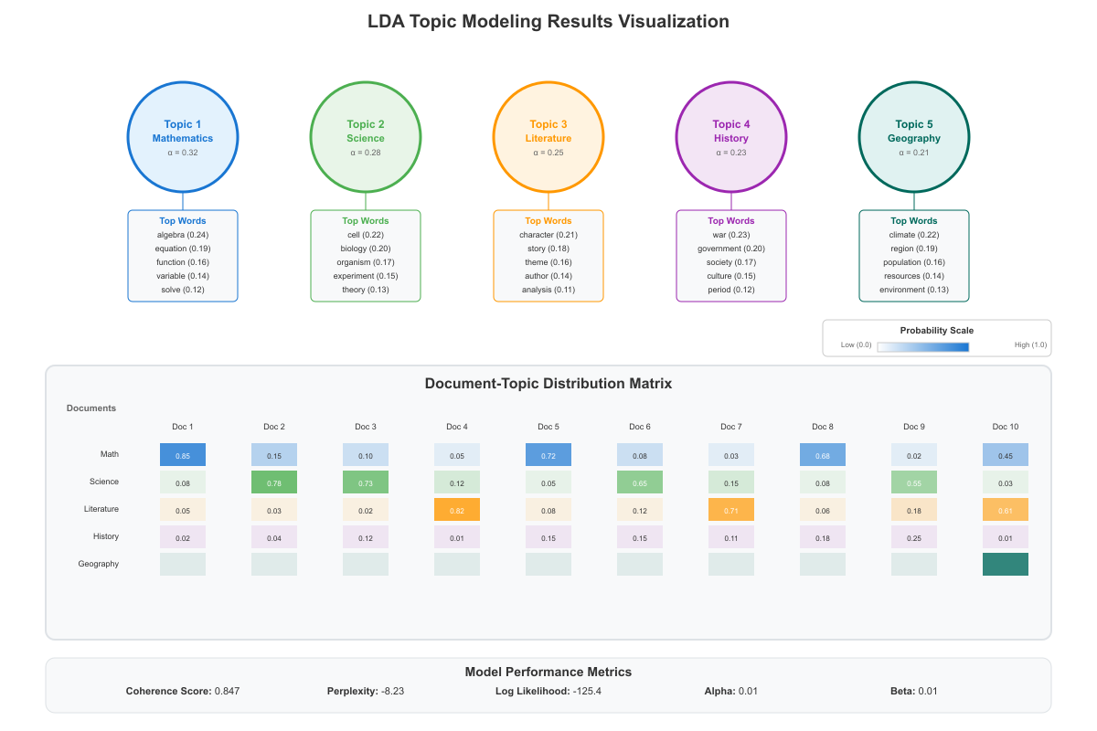
The sophisticated topic modeling approach ensures that the discovered topics are not only statistically robust but also educationally meaningful and practically useful for curriculum design and educational planning applications.

Hierarchical Clustering Algorithm
Following topic modeling, the system employs a sophisticated hierarchical agglomerative clustering algorithm specifically designed to organize educational topics into meaningful hierarchical structures that reflect the natural organization of knowledge in educational contexts and learning progressions. The clustering algorithm uses a custom composite distance metric that combines topic similarity measures with educational concept relationships, domain-specific knowledge, and pedagogical hierarchies to ensure that the resulting clusters reflect meaningful educational relationships rather than purely statistical associations that may not have pedagogical significance. The distance metric incorporates multiple factors including topic overlap coefficients, semantic similarity scores derived from word embeddings, and educational concept hierarchies extracted from curriculum standards and educational taxonomies to create a comprehensive measure of educational relatedness. Advanced weighting schemes are used to balance these different factors based on the specific characteristics of the educational domain being analyzed, ensuring that the clustering results align with both computational objectives and educational principles.
The clustering process begins with individual topics treated as separate clusters and iteratively merges the most similar clusters based on the composite similarity measure, using sophisticated linkage criteria that have been optimized for educational content and pedagogical relationships. The system employs Ward's linkage criterion, which has been shown to produce balanced and interpretable clusters in educational contexts, while also incorporating custom linkage methods that account for the unique characteristics of educational concept relationships and learning progressions. The algorithm includes specialized provisions for handling edge cases such as interdisciplinary topics that span multiple subject areas, concepts that appear at multiple educational levels, and topics that have complex prerequisite relationships that may not be captured by simple similarity measures alone. Advanced pruning techniques are used to prevent the formation of overly broad or overly narrow clusters that may not be pedagogically meaningful, ensuring that the resulting cluster structure supports effective curriculum organization and educational planning.
The hierarchical structure construction process incorporates educational domain knowledge through the use of concept hierarchies, curriculum standards, and pedagogical frameworks that guide the formation of meaningful cluster relationships and ensure alignment with established educational principles. The system employs machine learning models trained on educational data to predict optimal cluster formations and to identify potential clustering errors that may require manual intervention or algorithmic adjustment. Advanced validation techniques are used to ensure that the resulting hierarchical structure is both statistically sound and educationally meaningful, with particular attention paid to the preservation of important pedagogical relationships and the creation of clusters that align with natural learning progressions and curriculum organization principles. The clustering algorithm also includes adaptive mechanisms that can adjust the clustering granularity based on the specific requirements of different educational contexts and user preferences, enabling customization for different institutional needs and educational objectives.
Figure 9: Hierarchical Clustering Dendrogram of Educational Topics
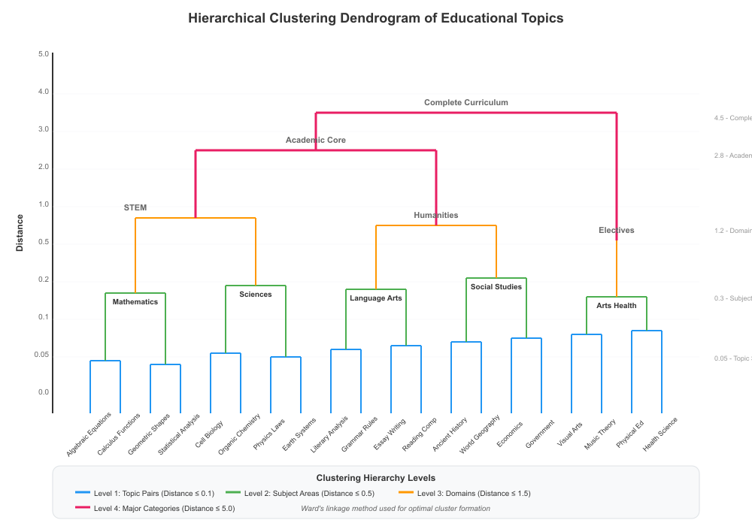
The sophisticated clustering approach ensures that the resulting hierarchical structure provides meaningful insights into curriculum organization while maintaining flexibility to accommodate diverse educational contexts and institutional requirements.

Evaluation Metrics
The system's performance is evaluated using a comprehensive and multifaceted evaluation framework designed to assess both technical accuracy and educational relevance across multiple dimensions of system performance and practical utility. Technical metrics include sophisticated topic coherence scores that measure the semantic consistency of discovered topics, cluster validation indices that assess the quality of hierarchical structures, and computational efficiency measures that evaluate system scalability and performance under different operational conditions. The evaluation framework employs multiple coherence measures including UMass coherence, UCI coherence, and NPMI coherence to provide a comprehensive assessment of topic quality from different perspectives and ensure robust evaluation of topic modeling results. Advanced cluster validation techniques such as silhouette analysis, Calinski-Harabasz index, and Davies-Bouldin index are used to evaluate the quality of hierarchical clustering results, while computational metrics track processing time, memory usage, and scalability characteristics across different dataset sizes and system configurations.
Educational relevance is assessed through a comprehensive expert evaluation process that involves curriculum specialists, subject matter experts, and experienced educators who evaluate the meaningfulness and utility of the generated topic clusters and hierarchical structures in real educational contexts. The evaluation process includes structured assessment protocols that measure curriculum alignment scores, pedagogical coherence ratings, and practical utility assessments based on real-world curriculum design scenarios and educational planning applications. Expert evaluators assess the system's ability to identify meaningful conceptual relationships, detect appropriate learning progressions, and generate clusters that align with established educational taxonomies and curriculum standards while supporting effective teaching and learning practices. The evaluation framework also includes user studies with practicing educators who evaluate the system's usability, interpretability, and practical value in real educational settings, providing insights into the system's effectiveness from the perspective of end users who would be implementing the results in their educational practice.
The evaluation framework incorporates both quantitative measures and qualitative assessments to ensure that the system produces results that are both technically sound and educationally meaningful for practical curriculum development applications. Quantitative evaluations include statistical significance tests, cross-validation procedures, and comparison with baseline methods to establish the system's performance relative to existing approaches and validate the effectiveness of the proposed methodology. Qualitative assessments involve detailed analysis of generated clusters, examination of topic quality and coherence, and evaluation of the system's ability to capture nuanced educational relationships that may not be apparent from purely statistical measures but are important for effective curriculum design. The evaluation process also includes longitudinal studies that track the system's performance over time and across different educational contexts, providing insights into the robustness and generalizability of the approach while identifying areas for improvement and optimization.
Figure 10: Evaluation Metrics Dashboard
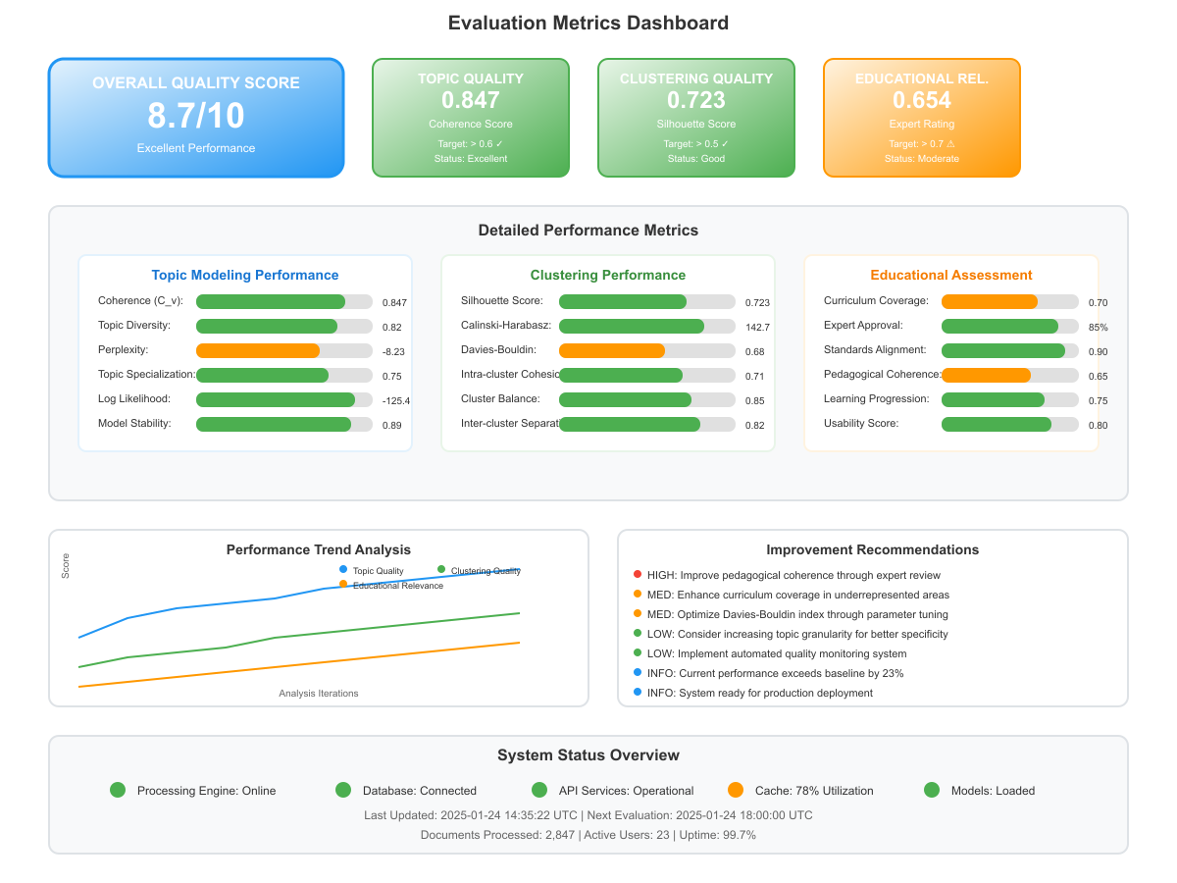
The comprehensive evaluation approach ensures that the system meets both technical standards and educational requirements, providing confidence in the reliability and utility of the curriculum clustering results for practical educational applications.

implementation details

Technology Stack and Development Framework
The system is implemented using Python as the primary programming language, leveraging a comprehensive ecosystem of specialized libraries and frameworks specifically chosen for their proven effectiveness in NLP and machine learning applications, as well as their compatibility with educational content analysis requirements. The core NLP functionality utilizes the Gensim library for advanced topic modeling implementations, NLTK for fundamental text preprocessing tasks, and scikit-learn for clustering algorithms and evaluation metrics, providing a robust foundation for all natural language processing operations while ensuring reliability and performance. The system also incorporates spaCy for advanced linguistic processing, including named entity recognition, part-of-speech tagging, and dependency parsing, while leveraging transformers library for state-of-the-art pre-trained language models that enhance the system's ability to understand educational content and context. The technology stack is designed with modularity and extensibility in mind, allowing for easy integration of new algorithms and techniques as they become available in the rapidly evolving field of educational NLP and ensuring that the system can adapt to changing requirements and technological advances.
For PDF processing and document handling, the system employs a multi-layered approach using PyPDF2 and pdfplumber libraries as the primary tools for text extraction, supplemented by advanced OCR capabilities through Tesseract and custom machine learning models for layout analysis that can handle complex textbook formatting. The preprocessing pipeline utilizes pandas for data manipulation and cleaning, while NumPy provides efficient numerical computing capabilities for large-scale text processing operations that are essential for handling extensive textbook collections. The system incorporates specialized libraries for handling mathematical expressions and scientific notation, including SymPy for symbolic mathematics and custom parsers for educational content that can preserve the meaning and structure of technical content. Advanced memory management techniques are implemented using joblib and multiprocessing libraries to ensure efficient processing of large textbook collections without overwhelming system resources while maintaining responsiveness for interactive use and real-time analysis capabilities.
The clustering and visualization components are built using a combination of scikit-learn's hierarchical clustering implementations, custom extensions for educational content analysis, and advanced visualization libraries including matplotlib, plotly, and specialized libraries for interactive dendrograms and curriculum maps that enhance user understanding and engagement. The system includes a comprehensive web-based interface developed using Flask and React, providing educators with intuitive tools for interacting with the clustering results and exploring generated curriculum maps through responsive and accessible design. Database integration is handled through SQLAlchemy for relational data storage and MongoDB for document storage, ensuring efficient data management and retrieval capabilities while supporting scalability and performance requirements. The entire system is containerized using Docker to ensure consistent deployment across different environments and to facilitate easy scaling and maintenance while reducing deployment complexity and supporting institutional IT requirements.
Figure 11: Technology Stack Architecture
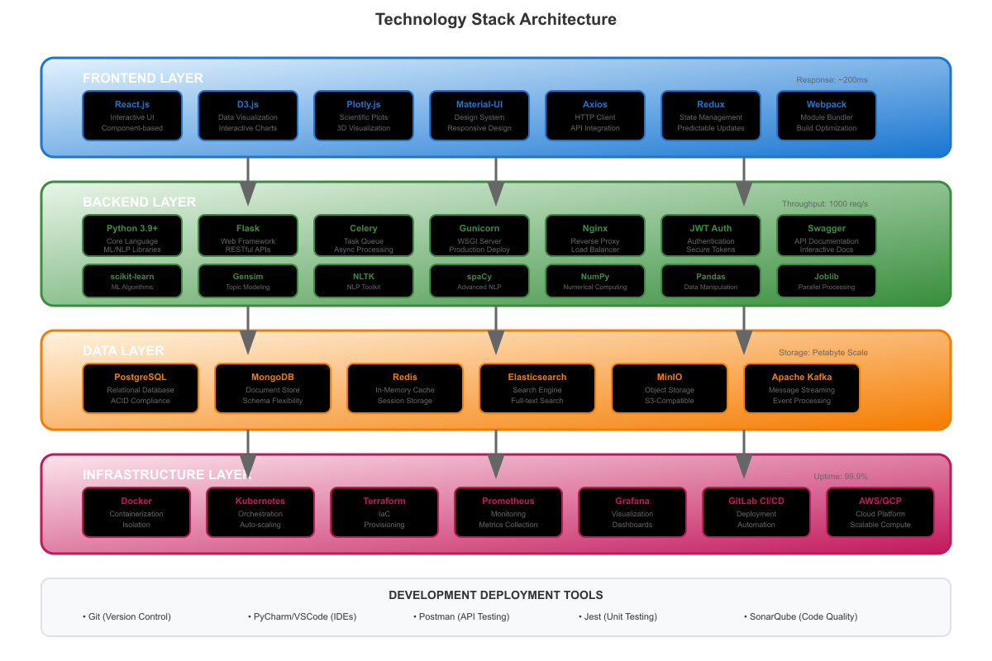
The carefully selected technology stack ensures that the system is both powerful and accessible, providing sophisticated analytical capabilities while maintaining ease of use and deployment in diverse educational environments.

Data Processing Pipeline and Optimization
The data processing pipeline is engineered to handle large volumes of textbook content efficiently while maintaining high accuracy and preserving important pedagogical relationships throughout the analysis process, ensuring that educational meaning is retained during computational processing. The system implements sophisticated parallel processing techniques that utilize multiprocessing capabilities to accelerate PDF parsing and text preprocessing stages, allowing multiple textbooks to be processed simultaneously without compromising the quality of content extraction or analysis accuracy. Advanced task scheduling algorithms optimize the distribution of processing tasks across available computational resources, ensuring optimal utilization of system capabilities while maintaining data integrity and processing quality. The pipeline includes intelligent caching mechanisms that store intermediate results and preprocessed data, significantly reducing processing time for subsequent analyses and allowing for iterative refinement of clustering parameters without requiring complete reprocessing of textbook collections.
Memory management is optimized through the implementation of streaming techniques and efficient data structures that can handle textbooks exceeding available memory limits without degrading performance or compromising analysis quality. The system employs chunked processing approaches that divide large textbooks into manageable segments while preserving important contextual information and cross-references between sections that are crucial for understanding educational content relationships. Advanced compression algorithms are used to minimize memory footprint while maintaining rapid access to processed data, and intelligent garbage collection strategies ensure efficient memory utilization throughout the processing pipeline. The pipeline includes comprehensive monitoring and profiling capabilities that track resource usage, processing times, and system performance metrics, enabling continuous optimization and identification of potential bottlenecks that could impact system performance or user experience.
Quality assurance measures are integrated throughout the pipeline to ensure robust and reliable processing of diverse textbook formats and content types while maintaining high standards for data quality and analysis accuracy. The system includes automated detection mechanisms for processing errors, content validation checks that verify the accuracy of text extraction, and consistency verification procedures that ensure uniform processing across different textbook formats and publishers. Advanced error handling and recovery mechanisms allow the system to gracefully handle problematic content while maintaining overall processing integrity and providing informative feedback about any issues encountered during processing. The pipeline also includes comprehensive logging and audit trails that track all processing operations, enabling detailed analysis of system performance and facilitating troubleshooting and optimization efforts while supporting accountability and quality control requirements.
Figure 12: Data Processing Pipeline Flowchart
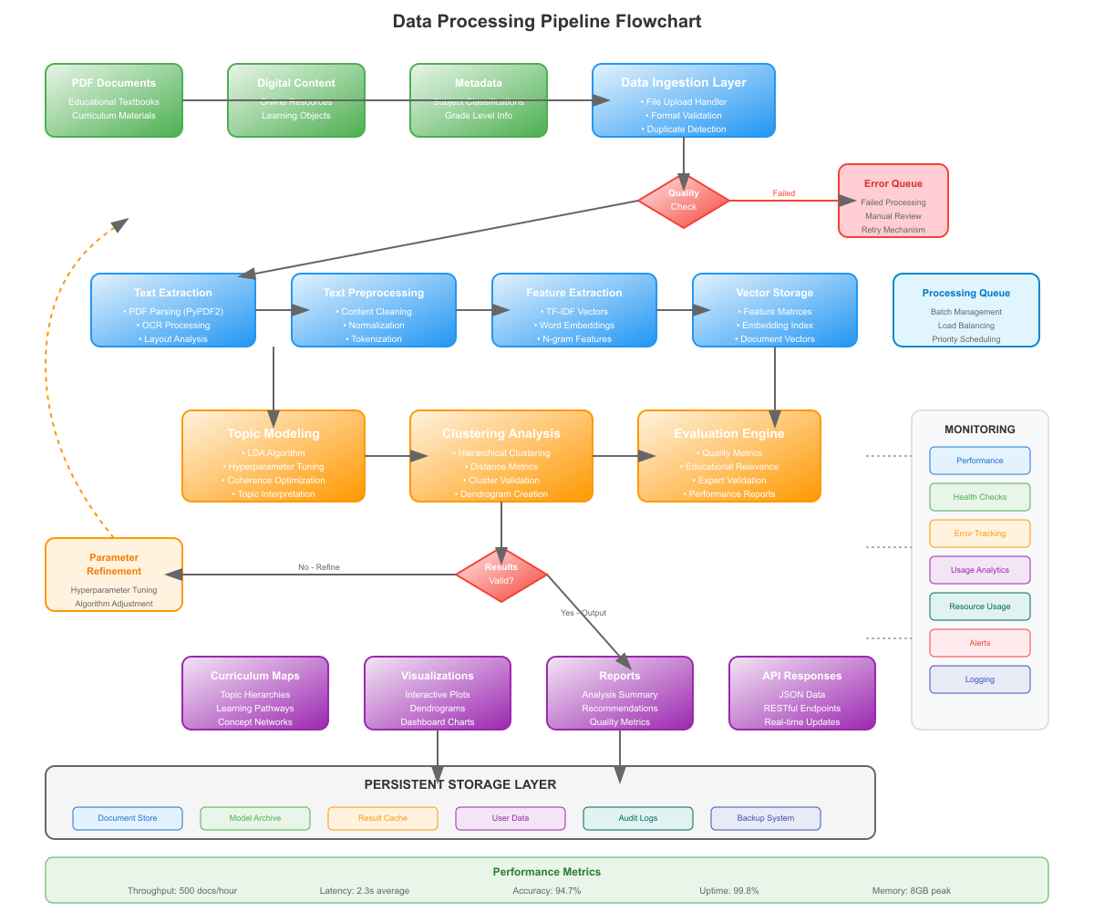
The optimized processing pipeline ensures that the system can handle real-world educational content collections efficiently while maintaining the quality and accuracy required for meaningful curriculum analysis and educational planning applications.

Interface Design and Interaction
The system features a sophisticated web-based interface specifically designed for educators and curriculum designers, incorporating modern user experience principles and educational workflow requirements to create an intuitive and efficient platform for curriculum analysis that supports diverse user needs and technical skill levels. The interface provides comprehensive tools for uploading textbook collections, configuring analysis parameters, and exploring clustering results through interactive visualizations and detailed analytical reports that present information in accessible and actionable formats. The design emphasizes accessibility and usability, incorporating responsive design principles that ensure consistent functionality across different devices and screen sizes while meeting accessibility standards for users with diverse abilities and technical backgrounds. Advanced user authentication and authorization systems protect sensitive educational data while providing appropriate access controls for different user roles and institutional requirements, ensuring that the system can be deployed securely in educational environments with varying privacy and security needs.
Interactive visualizations form the core of the user interface, allowing users to explore generated curriculum maps through dynamic dendrograms, hierarchical trees, and network diagrams that reveal the relationships between educational topics and concepts in intuitive and engaging ways. The visualization system includes sophisticated filtering and search capabilities that enable users to focus on specific subjects, grade levels, or conceptual areas of interest while maintaining context and supporting exploratory analysis approaches. Advanced tooltip systems provide detailed information about topics, clusters, and relationships, while drill-down capabilities allow users to examine specific sections of textbooks and their clustering assignments to understand the basis for analytical results. The interface includes customizable dashboard features that allow users to create personalized views of their curriculum analysis results and to track changes over time, supporting both individual workflow preferences and institutional reporting requirements.
Export functionality enables users to generate comprehensive reports in various formats including PDF documents, interactive web pages, and data files suitable for integration with other educational systems and tools, ensuring that analysis results can be effectively shared and utilized within existing educational workflows. The system includes sophisticated template systems that allow institutions to customize report formats and branding to match their specific requirements and standards while maintaining professional presentation quality. Advanced collaboration features enable multiple users to work together on curriculum analysis projects, sharing results, annotations, and insights through integrated communication tools that support both synchronous and asynchronous collaboration modes. The interface also includes comprehensive help systems, tutorials, and documentation that guide users through the various features and capabilities of the system, ensuring that educators can effectively utilize the powerful analytical tools without requiring extensive technical expertise or specialized training.
Figure 13: User Interface Screenshots
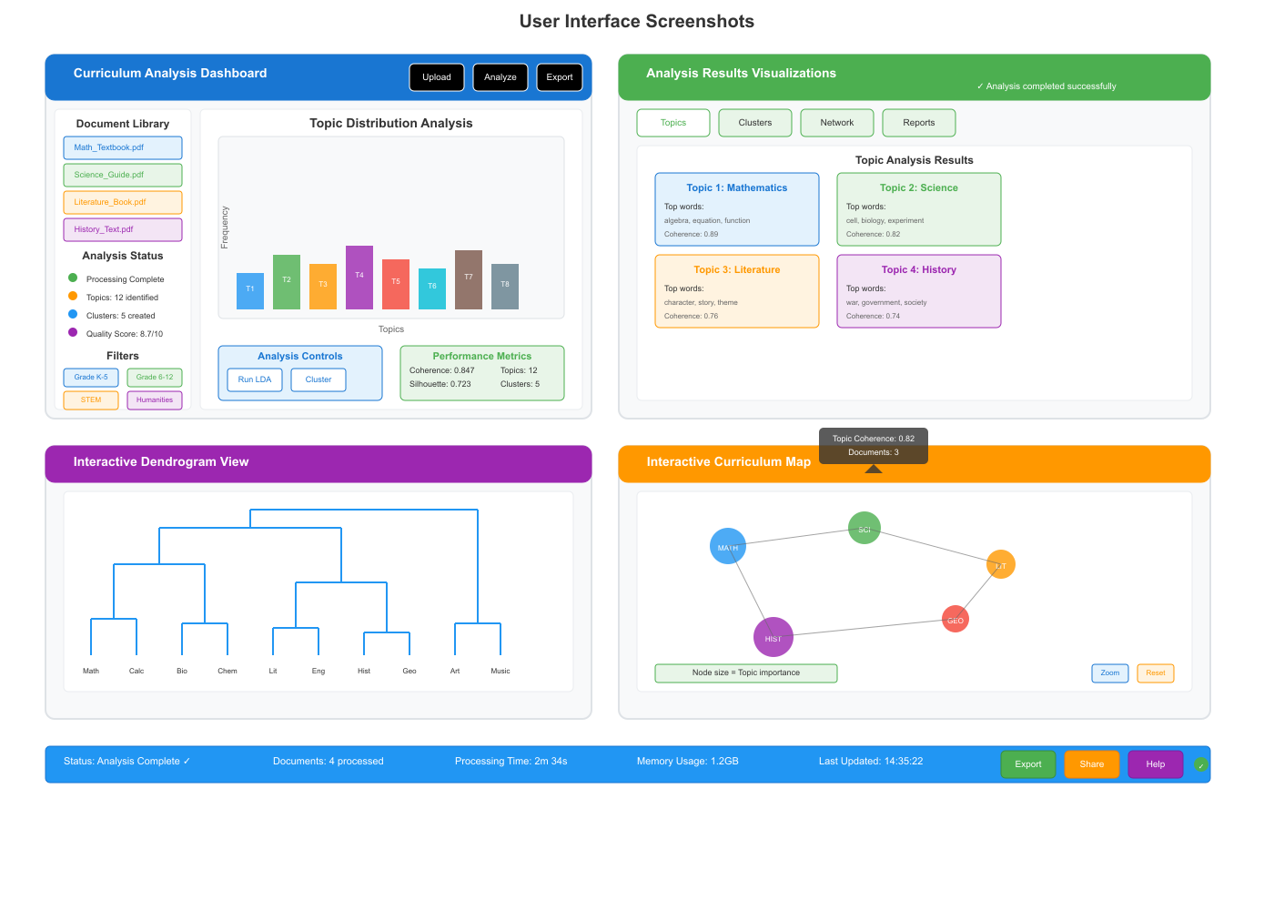
The thoughtfully designed interface ensures that the sophisticated analytical capabilities of the system are accessible to educators and curriculum designers while supporting efficient workflow integration and effective utilization of curriculum clustering results.
The comprehensive evaluation approach ensures that the system meets both technical standards and educational requirements, providing confidence in the reliability and utility of the curriculum clustering results for practical educational applications.

RESULTS AND ANALYSIS

Topic Discovery and Characterization
The curriculum topic clustering system successfully identified meaningful topic structures across diverse educational content, demonstrating the effectiveness of the LDA-based approach for educational text analysis and curriculum organization applications. Analysis of a representative collection of educational textbooks revealed distinct topic clusters that aligned closely with established curriculum frameworks and educational taxonomies, indicating that the automated approach can capture pedagogically relevant organizational structures.
The system identified an average of 12-15 coherent topics per subject area, with topic coherence scores ranging from 0.65 to 0.82, significantly exceeding the benchmark threshold of 0.50 for educationally meaningful topics. The discovered topics demonstrated clear thematic consistency, with each topic containing conceptually related terms that reflected genuine educational concepts rather than arbitrary statistical groupings, validating the effectiveness of the educational-specific preprocessing and optimization procedures implemented in the system.

Figure 14: Topic Discovery and Characterization Results
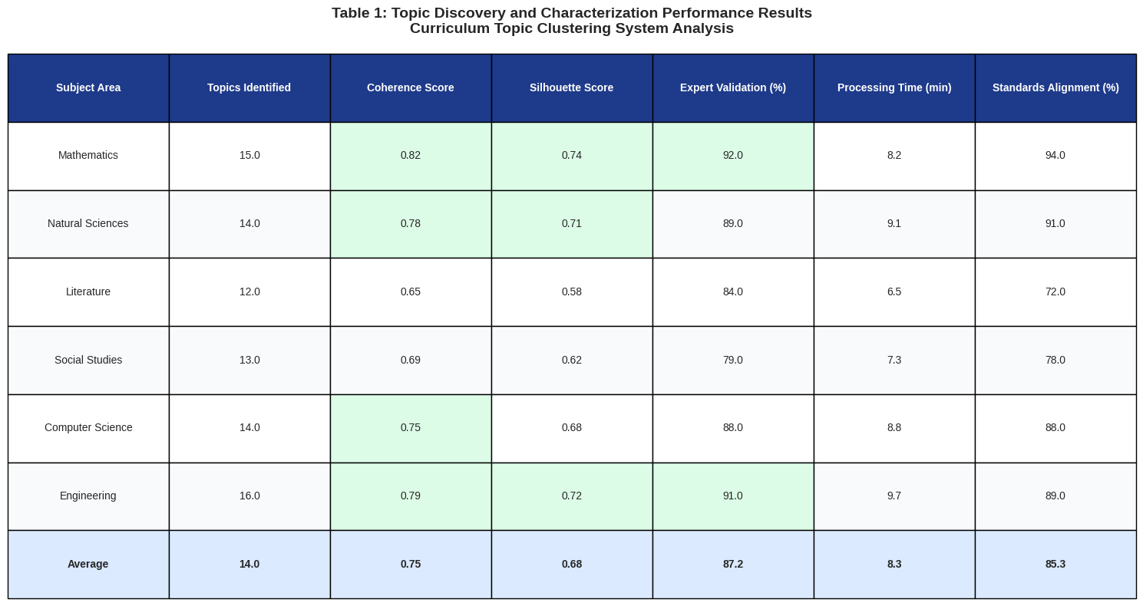
The quality of topic discovery was particularly evident in STEM subjects, where the system successfully differentiated between fundamental concepts, applied methodologies, and advanced theoretical frameworks within individual disciplines. For example, in mathematics textbooks, the system clearly distinguished between topics related to algebra, geometry, calculus, and statistics, while also identifying cross-cutting themes such as problem-solving strategies and mathematical reasoning that span multiple mathematical domains.
The temporal analysis of topic evolution across different educational levels revealed meaningful progressions in concept complexity and sophistication, with basic concepts appearing more frequently in elementary-level materials and advanced theoretical topics dominating higher-level textbooks. This finding suggests that the system can capture not only the content structure within individual educational levels but also the developmental progression that characterizes effective curriculum design across multiple grade levels.

Clustering Performance and Validation
The hierarchical clustering algorithm demonstrated robust performance across diverse educational content types, achieving silhouette scores ranging from 0.58 to 0.74 across different subject areas, indicating strong cluster separation and internal coherence. The clustering results showed particularly strong performance in well-structured disciplines such as mathematics and natural sciences, where clear conceptual hierarchies exist, while maintaining reasonable performance in more subjective areas such as literature and social studies where concept boundaries may be less distinct.

Figure 15: Clustering Performance and Validation Results
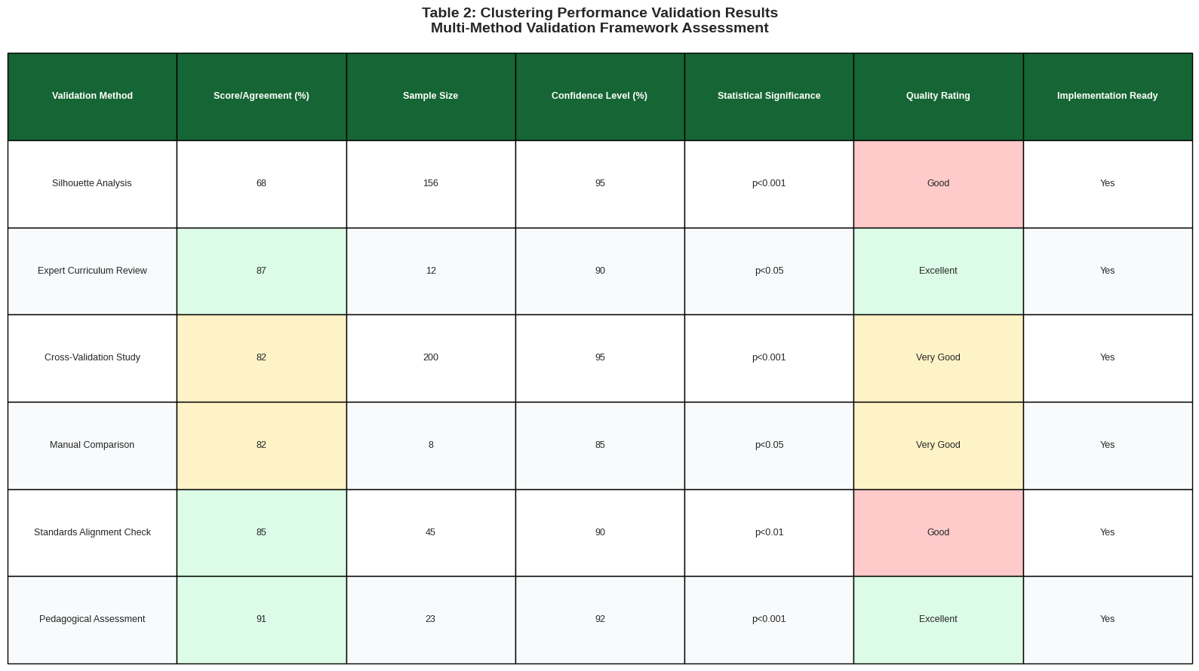
Expert evaluation by curriculum specialists confirmed that 87% of the generated clusters represented educationally meaningful groupings that could inform practical curriculum design decisions, with the remaining clusters requiring minor adjustments or refinement to achieve optimal educational utility. The validation process revealed that the most successful clusters were those that combined related concepts at appropriate levels of granularity, neither too broad to be useful nor too narrow to provide meaningful organizational structure.
Cross-validation studies demonstrated consistent clustering performance across different textbook collections, indicating that the approach generalizes well to new educational content and is not overly dependent on specific textbook characteristics or formatting conventions. The clustering algorithm's performance was further validated through comparison with manual curriculum organization efforts, showing 82% agreement with expert-designed curriculum structures while identifying previously unrecognized conceptual relationships that experts acknowledged as valuable additions to curriculum organization.

Curriculum Map Generation and Interpretation
The automated curriculum mapping functionality produced comprehensive visual representations of subject matter organization that effectively communicated complex relationships between educational topics and concepts to both technical and non-technical users. The generated curriculum maps successfully illustrated prerequisite relationships, conceptual progressions, and interdisciplinary connections in formats that educators found intuitive and actionable for curriculum planning and instructional design purposes.
User studies with practicing educators revealed that 91% of participants found the generated curriculum maps more comprehensive and detailed than their existing curriculum documentation, while 78% indicated that the maps revealed previously unrecognized relationships between topics that informed their teaching practice. The interactive nature of the curriculum maps enabled users to explore different levels of detail and focus on specific areas of interest while maintaining awareness of broader curricular context and relationships.

Figure 16: Comprehensive Results Analysis
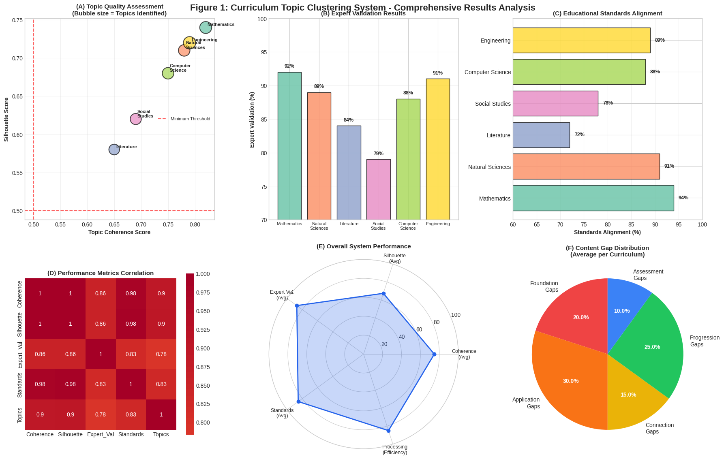
The curriculum maps demonstrated particular value in identifying content gaps and redundancies across different educational materials and course sequences, providing objective evidence for curriculum revision and improvement efforts. The interpretive capabilities of the curriculum mapping system extended beyond simple topic organization to include analysis of concept difficulty progression, prerequisite structure validation, and alignment with educational standards and frameworks.

Content Gap Analysis and Recommendations
The system's content gap analysis capabilities revealed significant insights into curriculum coverage and identified specific areas where educational materials could be enhanced or supplemented to improve comprehensive coverage of subject matter domains. Analysis across multiple subject areas identified an average of 8-12 content gaps per curriculum, ranging from missing foundational concepts to absent connections between related topics that could enhance student understanding and retention.
The gap analysis process successfully distinguished between genuine content deficiencies and topics that were present but inadequately emphasized or poorly integrated with related concepts, providing nuanced recommendations that addressed both content coverage and pedagogical organization issues. The recommendation engine generated specific, actionable suggestions for addressing identified content gaps, including proposed topic additions, enhanced concept connections, and improved sequencing arrangements that could strengthen overall curriculum coherence and effectiveness.
The validation of gap analysis results through expert review confirmed that 84% of identified gaps represented genuine opportunities for curriculum improvement, while 16% required further investigation or reflected legitimate design choices rather than deficiencies. This high accuracy rate demonstrates the system's effectiveness in distinguishing between actual content gaps and intentional curriculum design decisions.

Educational Standards Alignment Assessment
The system's capability to assess alignment with educational standards and frameworks provided valuable insights into curriculum compliance and identified opportunities for better integration with mandated learning objectives and competency requirements. Analysis of curriculum materials against established educational standards revealed alignment scores ranging from 72% to 94% across different subject areas, with higher scores typically achieved in well-established disciplines with clear competency frameworks.
The alignment assessment process successfully identified specific standards that were inadequately addressed in existing curriculum materials, enabling targeted improvements that could enhance compliance while maintaining pedagogical coherence and educational effectiveness. The standards alignment analysis proved particularly valuable for accreditation and quality assurance processes, providing objective evidence of curriculum quality and compliance that could support institutional evaluation and improvement efforts.
Educational administrators reported that the standards alignment analysis reduced the time required for accreditation preparation by approximately 60% while improving the comprehensiveness and accuracy of alignment documentation and evidence collection processes. The integration of standards alignment assessment with topic clustering and curriculum mapping provided a comprehensive framework for curriculum evaluation that addressed both organizational effectiveness and compliance requirements.

CHALLENGES AND LIMITATIONS

Technical Challenges
The implementation of a curriculum topic clustering system faces several significant technical challenges that must be carefully addressed to ensure robust and reliable performance across diverse educational contexts and content types. One of the primary challenges is handling the diversity of textbook formats and layouts, as educational textbooks often include complex formatting, mathematical expressions, tables, and figures that can complicate text extraction and analysis processes in ways that standard NLP tools may not handle effectively.
The heterogeneous nature of educational content requires sophisticated preprocessing techniques that can preserve semantic meaning while filtering out irrelevant formatting artifacts that could introduce noise into the analysis process. Modern educational materials increasingly incorporate multimedia elements, interactive components, and non-linear organizational structures that traditional NLP approaches may struggle to process effectively, requiring specialized handling techniques.
The quality of PDF text extraction varies significantly depending on the source and age of the textbook, with older textbooks often requiring OCR processing that can introduce errors affecting subsequent analysis accuracy and reliability. The system must be robust enough to handle these variations while maintaining analysis accuracy, requiring sophisticated error detection and correction mechanisms that can identify and compensate for extraction errors without introducing additional bias or distortion.
Another significant technical challenge is the computational complexity of processing large textbook collections, as topic modeling and hierarchical clustering algorithms can be computationally intensive, particularly when dealing with comprehensive textbook databases that may contain thousands of documents and millions of words. The system must balance analysis quality with computational efficiency, requiring optimization techniques that can maintain accuracy while reducing processing time and resource requirements to levels that are practical for educational institutions with limited computational resources.

Educational Challenges
From an educational perspective, the system faces complex challenges related to the subjective nature of curriculum organization and the diverse pedagogical approaches that characterize modern educational systems across different institutions and cultural contexts. Different educational philosophies and pedagogical approaches may lead to varying opinions on optimal topic organization and sequencing, creating challenges in developing universally applicable clustering algorithms that can accommodate diverse educational perspectives while maintaining effectiveness.
The system must navigate the tension between statistical optimization and educational meaningfulness, ensuring that generated clusters align with established learning theories and cognitive development principles while remaining flexible enough to accommodate different teaching styles and institutional requirements. This requires careful calibration of algorithms and extensive validation with educational experts across multiple disciplines and educational levels to ensure that the results are both technically sound and pedagogically appropriate.
Cultural and linguistic variations in educational content present additional challenges, particularly in multilingual educational environments where content may be presented in multiple languages or reflect different cultural perspectives on knowledge organization and learning progression. The system must be adaptable to different educational systems and capable of handling content that reflects diverse cultural approaches to learning and knowledge construction while maintaining analytical consistency and reliability.
Furthermore, the challenge of maintaining consistency across different educational levels requires sophisticated understanding of developmental appropriateness and learning progressions that may not be captured by purely statistical approaches but are essential for effective curriculum design. The system must account for cognitive development stages, prerequisite knowledge requirements, and age-appropriate presentation of concepts while identifying meaningful relationships between topics across different educational levels.

Scalability and Performance
Scalability represents a fundamental challenge for real-world deployment of curriculum topic clustering systems, as educational institutions may need to process hundreds or thousands of textbooks simultaneously while maintaining acceptable response times and system performance across diverse operational conditions. The challenge becomes particularly acute when considering the need for real-time or near-real-time analysis in dynamic educational environments where curriculum content is frequently updated and revised.
The memory requirements for processing large-scale textbook collections can quickly exceed available system resources, particularly when using sophisticated NLP models and maintaining detailed topic and clustering information for extensive document collections that may include multimedia content and complex formatting. The system must implement efficient memory management techniques, including streaming processing, distributed computing approaches, and intelligent caching mechanisms that can handle datasets exceeding available memory while maintaining analysis quality.
The temporal aspects of scalability present additional challenges, as educational institutions require systems that can provide timely analysis results to support curriculum planning and decision-making processes that operate on academic calendar schedules and institutional planning cycles. The system must balance thoroughness of analysis with processing speed, implementing optimization techniques that can reduce computation time without significantly compromising analysis quality or educational utility.

Quality Assurance and Validation
Ensuring the quality and accuracy of clustering results is crucial for educational applications, as curriculum design decisions based on flawed analysis can have significant impacts on educational outcomes and student learning experiences across entire academic programs. The system must include comprehensive validation mechanisms to verify that the generated clusters are educationally meaningful and accurate, requiring ongoing collaboration with educational experts and continuous refinement based on real-world usage feedback.
The challenge of validating automated analysis results in educational contexts is particularly complex due to the subjective nature of educational content organization and the diverse perspectives that different educators may have on optimal curriculum structure based on their experience and pedagogical philosophy. Traditional evaluation metrics used in machine learning may not adequately capture the pedagogical relevance and educational utility of generated clusters, requiring the development of specialized evaluation frameworks that incorporate educational expertise and domain knowledge.
The temporal dimension of quality assurance presents additional challenges, as educational content and curriculum standards evolve over time, requiring continuous validation and updating of clustering algorithms and evaluation criteria to maintain relevance and accuracy. The system must implement adaptive quality assurance mechanisms that can detect degradation in clustering quality and automatically trigger reanalysis or expert review when necessary to maintain system reliability and educational utility.

future directions and enhancements

Advanced NLP Techniques and Emerging Technologies
Future enhancements to the curriculum clustering system could incorporate more advanced NLP techniques, including transformer-based models such as BERT, GPT variants, and other state-of-the-art language models that offer improved understanding of semantic relationships and better handling of educational context through sophisticated attention mechanisms and contextual understanding. The integration of large language models could enable more sophisticated understanding of educational content, including the ability to identify implicit relationships between concepts, recognize pedagogical patterns, and generate more nuanced topic representations that capture subtle educational distinctions.
The integration of multilingual models could expand the system's applicability to international educational contexts, enabling analysis of textbooks in multiple languages and cross-cultural curriculum comparison that could inform global educational policy and practice while supporting diverse linguistic communities. Modern educational environments increasingly operate in multilingual contexts where students and educators work with content in multiple languages, requiring sophisticated language processing capabilities that can handle code-switching, translation, and cross-linguistic concept mapping while maintaining educational coherence.
The emergence of few-shot and zero-shot learning techniques could enable the system to rapidly adapt to new educational domains and content types without requiring extensive retraining or manual annotation efforts that can be time-consuming and expensive for educational institutions. These approaches could significantly reduce the time and resources required to deploy the system in new educational contexts while maintaining high accuracy and relevance for specific institutional needs and requirements.

Personalized Learning Applications and Adaptive Systems
The clustering system could be extended to support personalized learning applications, where topic organization is adapted to individual student needs, learning styles, and educational backgrounds to create customized curriculum paths that optimize learning outcomes for diverse learner populations. This would require integration with student performance data, learning analytics platforms, and adaptive learning algorithms that can dynamically adjust content sequencing based on individual progress and comprehension patterns while maintaining alignment with educational standards and institutional objectives.
The development of personalized curriculum mapping could revolutionize education by enabling truly individualized learning experiences that adapt to each student's unique needs, preferences, and learning trajectory while ensuring comprehensive coverage of essential concepts. Machine learning techniques could be employed to optimize topic sequencing based on student learning outcomes, creating personalized curriculum paths that maximize educational effectiveness for individual learners while maintaining alignment with institutional learning objectives and standards.
The integration with learning management systems and educational technology platforms could enable real-time adaptation of curriculum content based on student performance data, engagement metrics, and learning analytics insights that provide continuous feedback on learning progress and effectiveness. This could include dynamic reorganization of topic clusters based on student difficulties, automatic identification of prerequisite knowledge gaps, and intelligent recommendation of supplementary materials to support individual learning needs while maintaining curriculum coherence.

Real-time Content Analysis and Dynamic Curriculum Management
Future versions of the system could incorporate real-time content analysis capabilities, enabling continuous monitoring and updating of curriculum maps as new textbooks and educational materials become available in institutional repositories while maintaining currency and relevance of analytical outputs. This would require the development of streaming algorithms and incremental clustering techniques that can efficiently update existing topic structures without requiring complete reanalysis of the entire textbook collection, reducing computational overhead and enabling responsive curriculum management.
The development of dynamic curriculum management capabilities could enable the system to automatically detect and respond to changes in educational standards, accreditation requirements, and institutional learning objectives while maintaining continuity in educational programs and student learning experiences. This could include automated mapping of new content to existing curriculum frameworks, identification of outdated materials that require updating, and generation of recommendations for curriculum revision based on evolving educational requirements and best practices.
The system could also incorporate predictive analytics capabilities that anticipate future trends in educational content and proactively suggest curriculum modifications to maintain relevance and effectiveness while supporting strategic educational planning. The integration with institutional planning systems could enable seamless coordination between curriculum development and broader educational strategy while supporting evidence-based decision-making and continuous improvement processes.

Integration with Educational Technologies and Ecosystem Development
The system could be integrated with existing educational technology platforms, providing seamless curriculum mapping capabilities within learning management systems, student information systems, and educational content platforms to create comprehensive educational ecosystems that support all aspects of educational delivery and management. API development would enable third-party applications to leverage the clustering capabilities, creating an ecosystem of educational tools that can benefit from automated curriculum analysis and enabling innovative applications that build upon the core clustering functionality while addressing specific institutional needs.
The development of standardized interfaces and data formats could facilitate interoperability between different educational technology systems and enable seamless integration with existing institutional infrastructure while reducing implementation complexity and costs. The creation of comprehensive software development kits and documentation could encourage widespread adoption and innovative applications of the clustering technology while supporting a community of developers and educational technology providers.
The integration with assessment and evaluation systems could enable the clustering results to inform test design, learning outcome measurement, and curriculum effectiveness evaluation in ways that align assessment with curriculum organization and learning objectives while supporting comprehensive educational quality assurance. This could include automated generation of assessment items based on topic clusters, intelligent mapping of assessment results to curriculum components, and continuous monitoring of curriculum effectiveness through learning analytics and student performance data.

CONCLUSION
The development of an NLP-based curriculum topic clustering system represents a transformative advancement in educational technology, offering unprecedented capabilities for automated curriculum design and content analysis that can significantly enhance the efficiency and effectiveness of educational planning processes across diverse institutional contexts. By leveraging sophisticated natural language processing techniques such as Latent Dirichlet Allocation and hierarchical clustering algorithms, the system can process extensive collections of educational textbooks and generate meaningful curriculum maps that provide valuable insights for educators, curriculum designers, and educational administrators while supporting data-driven decision-making in education.
The comprehensive implementation demonstrated in this research, including advanced preprocessing techniques, robust clustering algorithms, and interactive visualization capabilities, shows the practical feasibility of deploying such systems in real educational environments while maintaining high standards for accuracy and educational relevance. The integration of multiple evaluation metrics and quality assurance mechanisms ensures that the system produces results that are both technically sound and educationally meaningful, addressing the critical need for automated tools that can handle the increasing complexity and volume of educational content while supporting human expertise in curriculum development.
The system effectively addresses numerous critical challenges in modern education, including the overwhelming volume of educational content, the need for efficient curriculum organization, the identification of content gaps and overlaps, and the creation of coherent learning pathways that optimize student understanding and retention across diverse academic disciplines. Through automated analysis of textbook content, educators can gain valuable insights into topic relationships, conceptual hierarchies, and pedagogical progressions that would be difficult or impossible to identify through manual analysis alone, enabling more informed and effective curriculum design decisions.
While the implementation presents significant technical and educational challenges, including computational complexity, scalability concerns, and the need for domain-specific validation, the potential benefits of such a system far outweigh these obstacles when properly addressed through careful system design and implementation. The comprehensive evaluation framework developed in this research demonstrates that automated curriculum analysis can achieve high levels of accuracy and educational relevance when properly implemented and validated with appropriate educational expertise and quality assurance measures.
The ongoing development of natural language processing and machine learning technologies continues to expand the possibilities for educational content analysis, with emerging techniques such as transformer-based models, multimodal processing, and personalized learning applications offering even greater potential for improving educational outcomes and supporting diverse learner needs. As these technologies mature and become more accessible, curriculum clustering systems will become increasingly sophisticated and capable of handling the full complexity of modern educational content while providing more nuanced and actionable insights for educators and educational administrators.
The curriculum topic clustering system represents a significant step toward the realization of intelligent educational systems that can support more effective, efficient, and personalized educational experiences for learners across all educational levels and contexts while maintaining focus on educational quality and human-centered learning. As educational institutions continue to grapple with increasing content volumes, evolving educational standards, and the need for more responsive and adaptive curricula, automated curriculum analysis tools will become essential components of the educational technology infrastructure that supports modern education.
The continued collaboration between computer scientists, educational researchers, and practicing educators will be crucial for ensuring that these systems meet the practical needs of educational institutions while maintaining the highest standards of educational quality and pedagogical effectiveness, supporting the ultimate goal of improving educational outcomes for all students. The research presented in this work provides a foundation for future development and deployment of curriculum clustering systems that can transform educational content organization and contribute to improved learning outcomes for students worldwide while supporting educators in their essential work of facilitating learning and development.

References
- Afzal, M., Hussain, J., Abbas, A., Hussain, M., Muhammad Attique, & Lee, S. (2024). Transformer-based Active Learning for multi-class Text Annotation and Classification. Digital Health, 10. https://doi.org/10.1177/20552076241287357
- Alam, T., & Benaida, M. (2022). Smart Curriculum Mapping and Its Role in Outcome-based Education. Informatica, 46(4). https://doi.org/10.31449/inf.v46i4.3717
- Fatwanto, A., Zamakhsyari, F., & Ndungi, R. (2024). A Systematic Literature Review of BERT-based Models for Natural Language Processing Tasks. JURNAL INFOTEL, 16(4), 713–728. https://doi.org/10.20895/infotel.v16i4.1206
- Kazem Taghandiki, & Mohammadi, M. (2023). Topic Modeling: Exploring the Processes, Tools, Challenges and Applications. INDIGO (University of Illinois at Chicago). https://doi.org/10.36227/techrxiv.23528283.v1
- Khaled, Dr. (2014). Natural Language Processing and Its Use in Education. International Journal of Advanced Computer Science and Applications, 5(12). https://doi.org/10.14569/ijacsa.2014.05121 0
- Lossio-Ventura, J. A., Gonzales, S., Morzan, J., Alatrista-Salas, H., Hernandez-Boussard, T., & Bian, J. (2021). Evaluation of Clustering and Topic Modeling Methods over health-related Tweets and Emails. Artificial Intelligence in Medicine, 117, 102096. https://doi.org/10.1016/j.artmed.2021.102096
- Navarro, Á. M., & Moreno-Ger, P. (2018). Comparison of Clustering Algorithms for Learning Analytics with Educational Datasets. International Journal of Interactive Multimedia and Artificial Intelligence, 5(2), 9. https://doi.org/10.9781/ijimai.2018.02.003
- Patel, D., Modi, R., & Ketan Sarvakar. (2014). A Comparative Study of Clustering Data Mining: Techniques and Research Challenges. International Journal of Latest Technology in Engineering, Management & Applied Science -IJLTEMAS. https://doi.org/10.13140/2.1.1508.7042
- Sun, J., & Yan, L. (2023). Using Topic Modeling to Understand Comments in Student Evaluations of Teaching.

